|  |
| --- |
| **ABS WHEEL SPEED SENSORS**  **CATALOGUE 2020**  **www.seinsa.es** |



**AABS WHEEL SPEED SENSORS**

**CATALOGUE 2020**

|  |
| --- |
|  |
|  |

|  |  |  |
| --- | --- | --- |
|  |  |  |
|  |

|  |
| --- |
| **ABS WHEEL SPEED SENSORS CATALOGUE 2020** |

ABS (Anti-lock Braking System) or Wheel speed sensors, are mounted in wheel hubs. Its function is to transfer the information about the speed of each wheel to the ABS control unit.   
If the ABS control unit detects a significant reduction in speed on one or more wheels, it modifies the braking pressure to prevent the wheels from locking up. Otherwise, you can lose the control of the vehicle.  
Not only the ABS system use the wheel speed sensors, other systems in the vehicle use its information (GPS, ASR, ESP, HAC...)

According to its functioning we can classify the sensors in two groups:

**1. Passive ABS sensors. For toothed wheels.**   
These types of sensors don’t need external power to generate a signal.  
They don’t begin to function until the toothed wheel (also named phonic wheel) reaches 3-7 km/h of speed.  
The sensor parts are: a permanent magnet, a polar rod and a copper coil around it. And it is situated in front of the toothed wheel at very little distance named an air gap.The magnetic flow generated by the magnet is modified by the teeth and troughs of the wheel and it generates a sinusoidal signal.  
In these types of sensors, the air gap is very important because its variation modifies the signal.

|  |  |
| --- | --- |
|  |  |

**2. Active ABS sensors. For wheels with magnetic codign/toothed wheels.**  
These types of sensors are based on the Hall effect and they need external power to ge-nerate signal. They can obtain measurements from 0 km/h.  
These sensors generate a square signal.

|  |  |  |  |  |
| --- | --- | --- | --- | --- |
| 2 |  | |  | |
|  |  | |  |
|  |

|  |  |
| --- | --- |
| **ABS WHEEL SPEED SENSORS CATALOGUE 2020** | |
| There are different types: | |
|  | - ABS Hall with magnetic coding ring. |
|  | - Magneto-resistive ABS sensor. |
|  | - ABS Hall sensor with permanent magnet. |

**ABS Hall with magnetic coding ring**

|  |  |  |
| --- | --- | --- |
| In this case, the toothed wheel is replaced by a coding ring with 48 pairs of magnets with alternating polarity (N/S). This magnetic ring is fitted within the wheel bearings.  The sensor has three elements of measurement which give | |  |
| the fnal signal. |  |

**Magneto-resistive ABS sensor (AMR)**

|  |  |  |  |  |
| --- | --- | --- | --- | --- |
| Base on ansiotropic magnetoresistance, that is a property | | |  | 3 |
| of certain materials in which the electric resistance de- | | |
| pends on the angle between the electric current and the | | |
| direction of magetization. | | |
| These sensors are very precise and can determine the | | |
| rotation speed and the direction (this is very useful for the | | |
| hill-start assist control, HAC). | | |
| **ABS Hall sensor with permanent magnet** | | |  |
| This sensor use a permanent magnet and the magnetic | | |
| coding ring is not necessary. | | |
| This magnet is located behind the semiconductor. This | | |
| allows for the use these types of sensors in transmissions | | |
| with toothed wheels. | | |
|  |  |  |
|  |

|  |
| --- |
| **ABS WHEEL SPEED SENSORS CATALOGUE 2020** |

**WHEN TO CHANGE THE ABS SENSOR?**

If the ABS indicator lights up or if the wheels lock up in normal braking

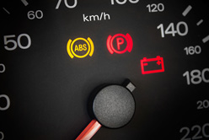

Causes:

Signal loss caused by cable break.  
Cracks, breaks or tension caused by mechanical stress.  
Deformation and dents caused by impacts or overheating.  
Short-circuit or internal breakage by mechanical or thermal stress.

**HOW TO REPAIR?**

- Unscrew the sensor and release the bushings.  
- Unplug the connector.  
- Remove the old sensor.  
- Clean the location of the sensor.  
- Put the new sensor and screw it in.  
- Plug the connector.  
- Fit all the bushings in their specific location.

**MEASUREMENTS IN CATALOGUE**

**B**

**A**

**A**

|  |  |  |  |
| --- | --- | --- | --- |
| 4 |  |  |  |
|  |

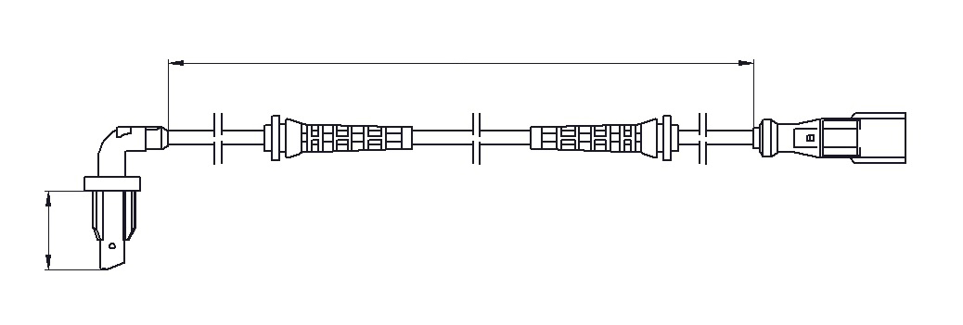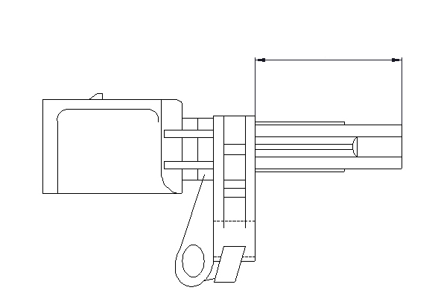

|  |  |  |  |  |  |  |  |  |  |  |  |  |
| --- | --- | --- | --- | --- | --- | --- | --- | --- | --- | --- | --- | --- |
| **DS0001** | | | | |  | **DS0002** | | | | | |  |
| **Active sensor** | | | **VAG** **VAG** | | 7H0927803 | **VAG**   **VAG** | | | | | | 7H0927804 |
| WHT003857 |
| WHT003856 |
| A = | 27,7 | mm | B = | mm | A = | | 27,7 | mm | B = | mm |
| **DS0003** | | | | |  | **DS0004** | | | | | |  |
| **VAG**   **VAG**  **VAG** | | | | | 6Q0927804A | **VAG**   **VAG** | | | | | | 6Q0927803B |
| 6Q0927804B |
| WHT003861 |
| WHT003860 |
| A = | 21 | mm | B = | mm | A = | | 21 | mm | B = | mm |
| **DS0005** | | | | |  | **DS0006** | | | | | |  |
| **Active sensor** | | | **VAG** **VAG** | | 1K0927807 | **Active sensor** | | | | **VAG** **VAG** | | 6Q0927807B |
| WHT003859 | WHT003863 |
| A = | 39,7 | mm | B = | mm | A = | | 23,8 | mm | B = | mm |
| **DS0007** | | | | |  | **DS0008** | | | | | |  |
| **Active sensor** | | | **VAG** **VAG** | | 6Q0927808B | **Active sensor** | | | | **VAG** **VAG** | | 1K0927808 |
| WHT003862 |
| WHT003858 |
| A = | 24,2 | mm | B = | mm | A = | 30,7 | | mm | B = | mm |
| **DS0009** | | | | |  | **DS0010** | | | | | |  |
| **VAG**   **VAG**  **BENTLEY** **BENTLEY** | | | | | 4E0927803D | **VAG**   **VAG**  **BENTLEY** **BENTLEY** | | | | | | 4E0927804D |
| 4E0927803F |
| 4E0927804F |
| 4E0927803 |
| 4E0927804 |
| 4E0927803A |
| 4E0927804A |
| A = | 37 | mm | B = | mm |  | A = | | 37 | mm | B = | mm | 5 |
|  |  | | | | |
|  | | | | | |

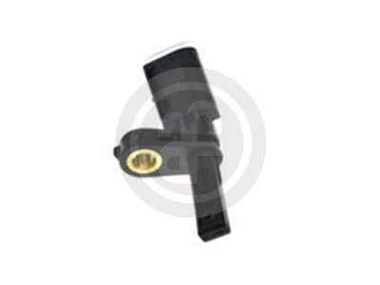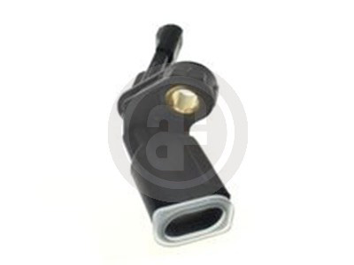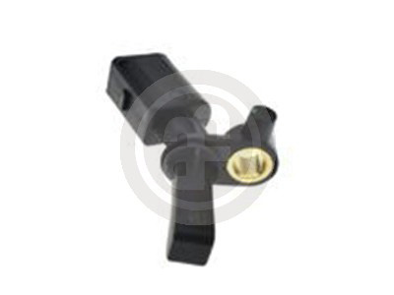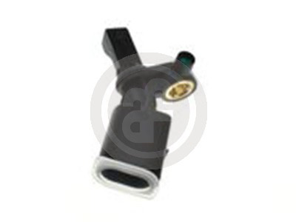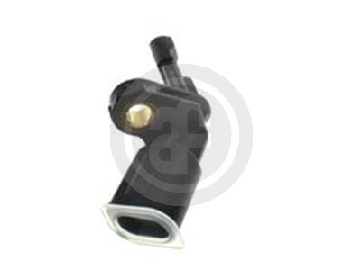

|  |  |  |  |  |  |  |  |  |  |  |  |  |  |  |  |  |  |  |  |
| --- | --- | --- | --- | --- | --- | --- | --- | --- | --- | --- | --- | --- | --- | --- | --- | --- | --- | --- | --- |
| |  | | --- | | **DS0011** | | | | | | | | | | | | **DS0012** | | | | |  |  |  |
| **Active sensor** | | | | | | **VAG** | | | | 1J0927807B | **Passive sensor** | | | | | 980mm | **VAG** | 4B0927803C |
| **VAG** | 8D0927803B |
| A = | 37,3 | | | mm | B = | mm | | | | | A = | | 39,8 | mm | B = | **VAG** | 8D0927803C |
| **VAG** | 8D0927803D |
| |  | | --- | | **DS0013 (coming soon)** | | | | | | | | | | | | **DS0014** | | | | |  |  |  |
| **Active sensor** | | | | | | **VAG** **VAG** | | | | WHT003864A | **Passive sensor** | | | | | mm | **VAG** | 1H0927807 |
| WHT003864B |
| **VAG** | 1J0927803 |
| A = | 37,9 | | | mm | B = | mm | | | | | A = | | 27,7 | mm | B = |
| |  | | --- | | **DS0015** | | | | | | | | | | | | **DS0016** | | | | |  |  |  |
| **Passive sensor** | | | | | | | | **VAG** | | 1H0927808 | **Passive sensor** | | | | | 1068mm | **VAG** | 8D0927803 |
| **VAG** | | 1J0927804 |
| A = | | | mm B = | | | mm | | | | | A = | | 39,8 | mm | B = |
| |  | | --- | | **DS0017** | | | | | | | | | | | | **DS0018** | | | | |  |  |  |
| **Active sensor** | | | | | | **VAG** | | | | 2K0927807 | **Active sensor** | | | | | 585mm | **DACIA** | 479101292R |
| **VAG** | | | | WHT003864 |
| **DACIA** | 8200195825 |
| A = | 37,9 | | | mm | B = | mm | | | | | A = | 23,6 | | mm | B = | **DACIA** | 8200419177 |
| **RENAULT** | 479101292R |
| **RENAULT** | 8200195825 |
| **RENAULT** | 8200419177 |
| |  | | --- | | **DS0020** | | | | | | | | | | | | **DS0021** | | | | |  |  |  |
| **Active sensor** | | | | | | | **FORD** | | | 1223622,1225843 | **Active sensor** | | | | | mm | **FORD** | 1223620 |
| **FORD** | | | 1481190,1695086 |
| **FORD** | 1690865 |
| **FORD** | | | | | | | | | | 1847905 | | | | | |
| **FORD** | 1847581 |
| **FORD** **FORD** | | | | | | | | | | 3M5T2B372BC 3M5T2B372BD | | | | | |
| **FORD** | 3M5T2B372AB |
| **FORD** | | | | | | | | | | BV6T2C190GA | | | | | | **FORD** | BV6T2C204FA |
| **FORD** | | | | | | | | | | BV6T2C190GB | | | | | |
| **FORD** | BV6T2C204FB |
| **MAZDA** | | | | | | | | | | BP4K43711A | | | | | |
| **MAZDA** | BP4K43701A |
| **MAZDA** | | | | | | | | | | BP4K43711B | | | | | |
| **VOLVO** | 9475557 |
| **VOLVO** | | | | | | | | | | 30648986, | | | | | |
| A = | | 14 | | mm | B = | mm | | | **VOLVO** | 30793635 | A = | | 24,8 | mm | B = |
| **VOLVO** | 31274612 |
| 6 | | | | | | | | | |  |  |  | | | |
|  | | | |

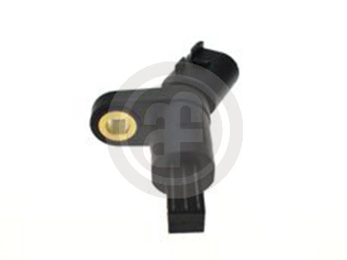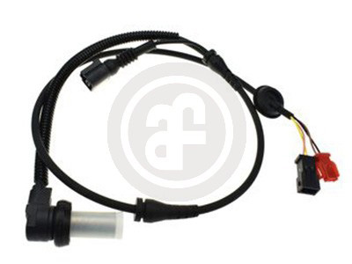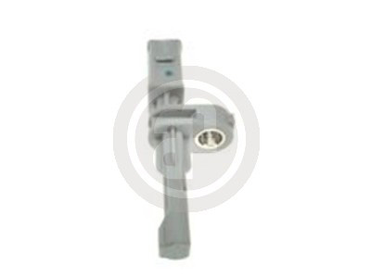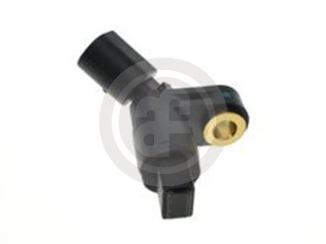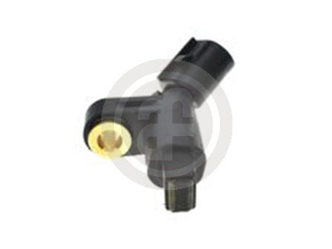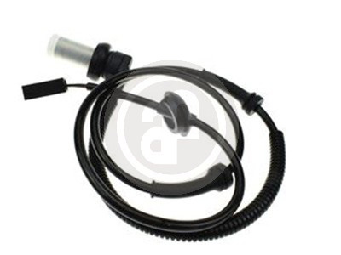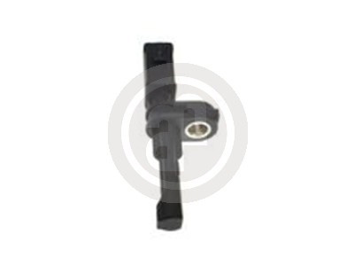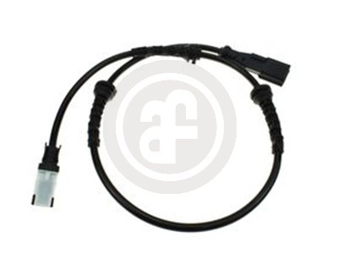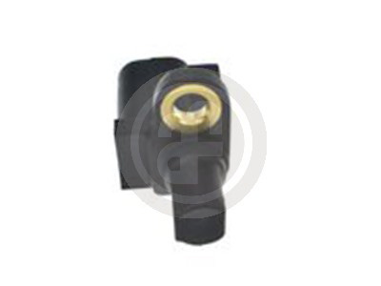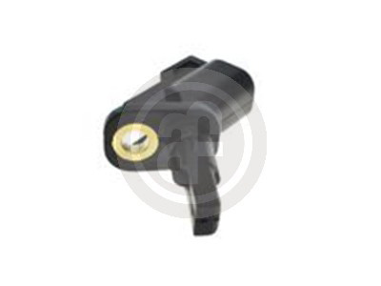

|  |  |  |  |  |  |  |  |  |  |  |  |  |  |  |  |
| --- | --- | --- | --- | --- | --- | --- | --- | --- | --- | --- | --- | --- | --- | --- | --- |
| **DS0022** | | | | |  | |  | | --- | | **DS0023 (coming soon)** | | | | | | | | | |
| **Active sensor** | | | | **DACIA**  **DACIA** | 479007380R | **Passive sensor** | | | | | **VAG** | 3B0927807B | | |
| 8200752605 |
| **VAG** | 3B0927807C | | |
| **LADA** | | | | | 479007380R |
| **VAG** | | | | | | 8E0927807 | | |
| **LADA** | | | | | 8200752605 |
| **RENAULT** | | | | | 479007380R | A = | | 43,8 | mm | B = | 1035mm | | | |
| **RENAULT** | | | | | 8200752605 |
| A = | 27,8 | mm | B = | 508mm |
| **DS0024** | | | | |  | |  | | --- | | **DS0025** | | | | | | | | | |
| **Active sensor** | | | | **FORD**  **FORD** | 1067210 | **Active sensor** | | | | | **DACIA** | | 479000527R | |
| 1088606 |
| **DACIA** | | 8200752604 | |
| **FORD** | | | | | 98AG2B372CB |
| **RENAULT** | | | | | | | | 479000527R |
| **FORD** | | | | | 98AG2B372CC |
| **RENAULT** | | | | | | | | 8200752604 |
| A = | 14 | mm | B = | 515mm | A = | | 27,8 | mm | B = | 461mm | | | |
| **DS0026** | | | | |  | |  | | --- | | **DS0027** | | | | | | | | | |
| **Active sensor** | | | | **FORD** **FORD** | 1356184 | **Passive sensor** | | | | | **VAG** | 6N0927807A | | |
| 3M5T2B372DA |
| A = | 25 | mm | B = | mm | A = | | 35,5 | mm | B = | 840mm | | | |
| **DS0028** | | | | |  | |  | | --- | | **DS0029 (coming soon)** | | | | | | | | | |
| **Active sensor** | | | | **PSA** **PSA** | 4545F5 | **Active sensor** | | | | | **VAG** | 1K0927808A | | |
| 4545K3 |
| **VAG** | WHT003858A | | |
| A = | mm B = | | | 617mm | **VAG** | | | | | | WHT003858B | | |
| A = | 39,7 | | mm | B = | mm | | | |
| **DS0030** | | | | |  | |  | | --- | | **DS0031** | | | | | | | | | |
| **VAG** | | | | | 8E0927807G | **VAG** | | | | | | 4B0927803B | | |
| A = | 28 | mm | B = | 1372mm |  | A = | | 27 | mm | B = | 980mm | | | |
|  |  | | | | | | | |
|  | | | | | 7 | | | |

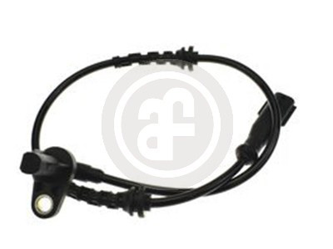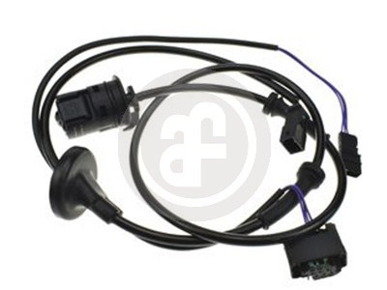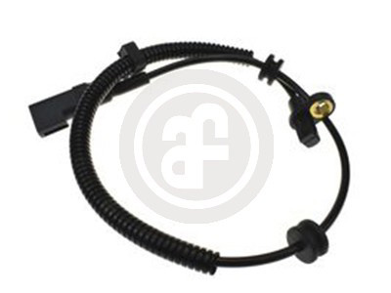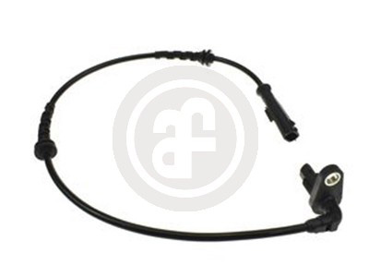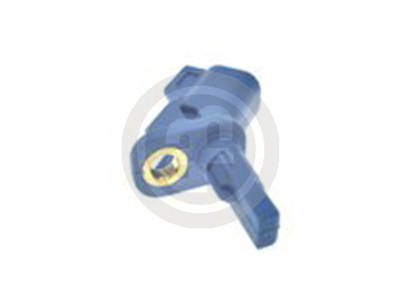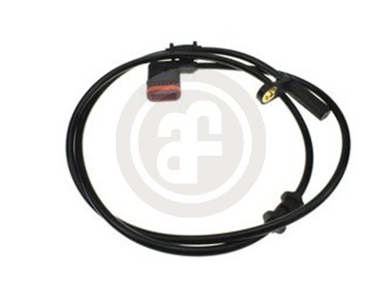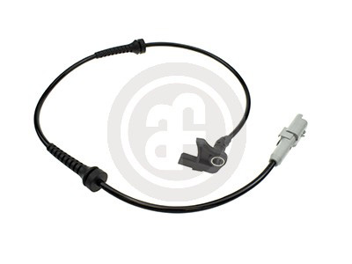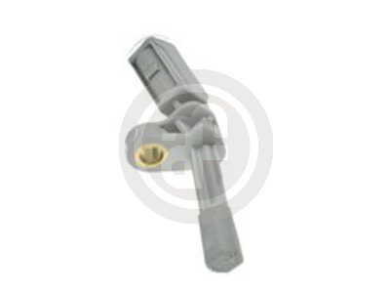

|  |  |  |  |  |  |  |  |  |  |  |  |  |  |  |  |  |
| --- | --- | --- | --- | --- | --- | --- | --- | --- | --- | --- | --- | --- | --- | --- | --- | --- |
| |  | | --- | | **DS0032 (coming soon)** | | | | | | | | | |  | | --- | | **DS0033 (coming soon)** | | | | | | | |
| **Active sensor** | | | | | **VAG** | 1K0927807A | | **VAG**   **VAG**  **PORSCHE** **PORSCHE** **PORSCHE** | | | | | | 7L0927807B |
| **VAG** | WHT003859A | |
| WHT003857B |
| **VAG** | WHT003859B | |
| 95560640510 |
| 95560640511 |
| 95560640512 |
| A = | 39,7 | | mm | B = | mm | | | A = | | 27,7 | mm | B = | mm | |
| |  | | --- | | **DS0034** | | | | | | | | | |  | | --- | | **DS0035 (coming soon)** | | | | | | | |
| **Passive sensor** | | | | | **RENAULT** | | 7700411747 | **Active sensor** | | | | | **VAG** | 7L0927808B |
| **VAG** | WHT003856A |
| **VAG** | | | | | | | | | | | | | | WHT003856B |
| **PORSCHE** | | | | | | | | | | | | | | 95560640610 |
| **PORSCHE** | | | | | | | | | | | | | | 95560640611 |
| **PORSCHE** | | | | | | | | | | | | | | 95560640612 |
| A = | 28,1 | | mm | B = | 446mm | | | A = | | 27,7 | mm | B = | mm | |
| |  | | --- | | **DS0036** | | | | | | | | | |  | | --- | | **DS0037** | | | | | | | |
| **Passive sensor** | | | | | **RENAULT** | | 7700429113 | **Passive sensor** | | | | | **VAG** | 3B0927807G |
| **RENAULT** | | 7700832768 |
| A = | 28,4 | | mm | B = | 605mm | | | A = | | 28 | mm | B = | 1120mm | |
| |  | | --- | | **DS0038** | | | | | | | | | |  | | --- | | **DS0039** | | | | | | | |
| **OPEL**  **OPEL** | | | | | | 1238236 | | **Active sensor** | | | | | **RENAULT** | 8200404460 |
| 9115064 | |
| A = | 28,5 | | mm | B = | 373mm | | | A = | 12,5 | | mm | B = | 720mm | |
| |  | | --- | | **DS0040 (coming soon)** | | | | | | | | | |  | | --- | | **DS0041** | | | | | | | |
| **FORD** **FORD** **FORD** **FORD** **FORD** **FORD** | | | | | | 1682670 | | **Active sensor** | | | | | **PSA** | 45450000 |
| 1756081 | |
| **PSA** | 4545J9 |
| 2070182 | |
| AV6T2B372EA | |
| AV6T2B372EB | |
| AV6T2B372EC | |
| A = | | 14 | mm | B = | mm | | | A = | | 34,4 | mm | B = | 975mm | |
| 8 | | | | |  | | |  |  | | | | | |
|  | | | | | |

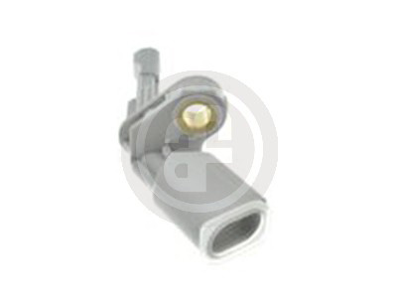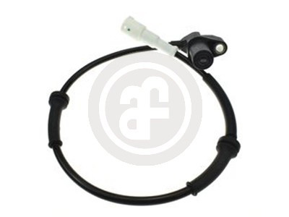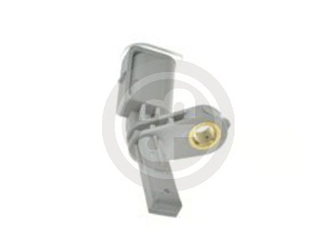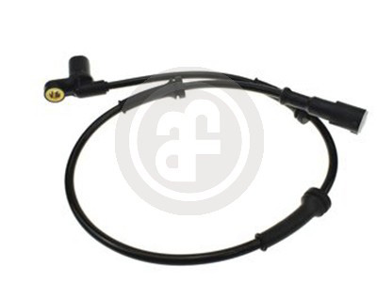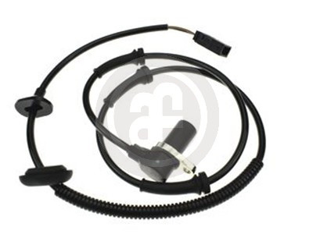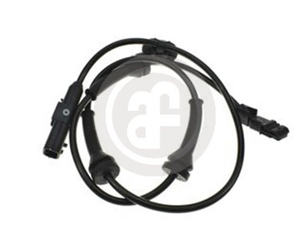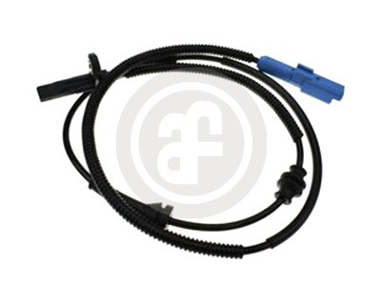

|  |  |  |  |  |  |  |  |  |  |  |  |  |  |  |
| --- | --- | --- | --- | --- | --- | --- | --- | --- | --- | --- | --- | --- | --- | --- |
| **DS0042** | | | |  | **RENAULT** | 8200416683 | | **DS0043** | | | | | |  |
| **Active sensor** | | | | 817mm | **Active sensor** | | | | **ABARTH**  **OPEL** | | 55700425 |
| 1238399 |
| A = | 12,5 | mm | B = | **OPEL** | | | | | | 1247506 |
| **OPEL** | | | | | | 13381153 |
| **OPEL** | | | | | | 6235742 |
| **OPEL** | | | | | | 93189275 |
| **OPEL** | | | | | | 93191478 |
| A = | | 28,1 | mm | B = | 770mm |
| **DS0044** | | | |  | **PEUGEOT** | 454599 | | **DS0045** | | | | | |  |
| **Active sensor** | | | | 755mm | **DACIA**  **DACIA** **RENAULT** **RENAULT** | | | | | | 479100004R |
| **PEUGEOT** | 4545F4 | |
| A = | 26 | mm | B = | 479109155R |
| 479100004R |
| 479109155R |
| A = | | 38,2 | mm | B = | 620mm |
| **DS0046** | | | |  | **RENAULT** | 8200186294 | | **DS0047** | | | | | |  |
| **Active sensor** | | | | 495mm | **PEUGEOT** | | | | | | 4545A3 |
| A = | 28 | mm | B = | A = | | 43,9 | mm | B = | 775mm |
| **DS0048** | | | |  | **ALFA ROMEO,** | | 52012826 | **DS0049** | | | | | |  |
| **Active sensor** | | | | 615mm | **Passive sensor** | | | | **PEUGEOT** | | 454576 |
| **ABARTH, FIAT** | | 52070363 |
| A = | 28 | mm | B = | 55700426 | | | A = | 25,5 | | mm | B = | 765mm |
| **FIAT** | 55701387 | |
| **FIAT** | 55703974 | |
| **OPEL** | 1229098 | |
| **OPEL** | 13381328 | |
| **OPEL** | 6235747 | |
| **OPEL** | 93189276 | |
| **DS0050** | | | |  | **PEUGEOT** | 454577 | | **DS0051** | | | | | |  |
| **Passive sensor** | | | | 782mm | **Active sensor** | | | | **PSA** | | 4545C1 |
| **PEUGEOT** | 454579 | |
| A = | 40,5 | mm | B = |  | | | A = | | 12,6 | mm | B = | 630mm | 9 |
|  |  | | | | |
|  | | | | | |

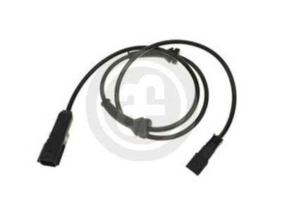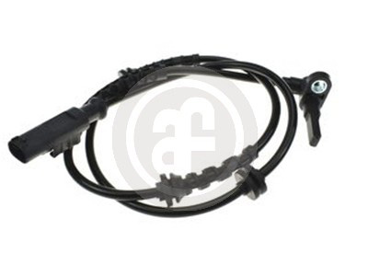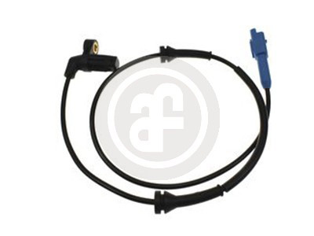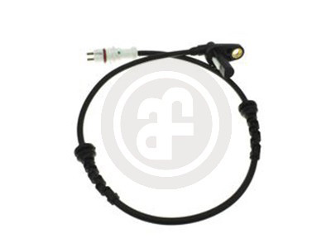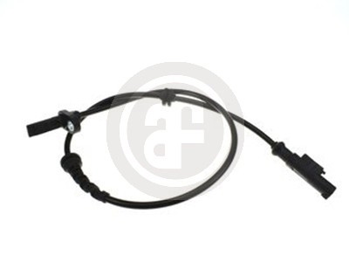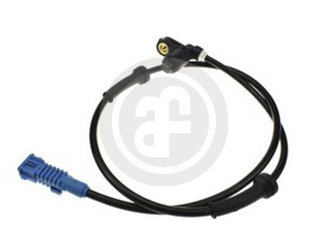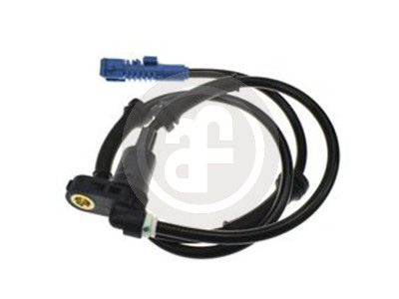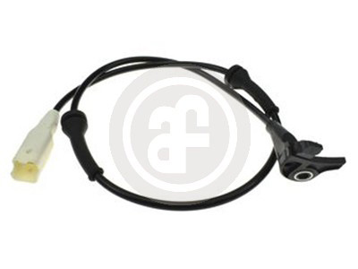

|  |  |  |  |  |  |  |  |  |  |  |  |  |  |  |
| --- | --- | --- | --- | --- | --- | --- | --- | --- | --- | --- | --- | --- | --- | --- |
| **DS0052** | | | | | |  | **DS0053** | | | | | | |  |
| **Active sensor** | | | | **PSA** | | 4545C4 | **Active sensor** | | | | | | **PEUGEOT** | 4545A0 |
| A = | mm B = | | | 720mm | | A = | | | 32 | mm | B = | 773mm |
| **DS0054** | | | | | |  | **DS0055** | | | | | | |  |
| **Active sensor** | | | | **FORD**  **FORD** | | 1064227 | **Active sensor** | | | | | | **FORD**  **FORD** | 1067208 |
| 1093743 |
| 1088635 |
| **FORD** | | | | | | 98AG2B372AE |
| **FORD** | | | | | | | 98AG2B372BE |
| **FORD** | | | | | | 98AG2B372AF |
| **FORD** | | | | | | | 98AG2B372BF |
| A = | 25 | mm | B = | 507mm | | A = | | | 14 | mm | B = | 630mm |
| **DS0056** | | | | | |  | **DS0057** | | | | | | |  |
| **RENAULT**  **RENAULT** | | | | | | 8200043136 | **RENAULT** | | | | | | | 8200446282 |
| 8200296571 |
| A = | 12,5 | mm | B = | 835mm | | A = | | 12,5 | | mm | B = | 758mm |
| **DS0058** | | | | | |  | **DS0059** | | | | | | |  |
| **Passive sensor** A = 40,5mmB = 761mm | | | | | **RENAULT** | 6000073527 | **RENAULT** | | | | | | | 6000073528 |
| A = | 40,5 | | | mm | B = | 1638mm |
| **DS0060** | | | | | |  | **DS0061** | | | | | | |  |
| **Active sensor** | | | | **LEXUS** **TOYOTA** | | 8954360050 | **Active sensor** | | | | | | **PSA** **PSA** | 4545C2 |
| 8954360050 |
| 96526967 |
| A = | 27,6 | mm | B = | mm | |  | A = | | | | mm B = | | 708mm |
|  |  | | | | | |
| 10 | | | | | |
|  | | | | | | |

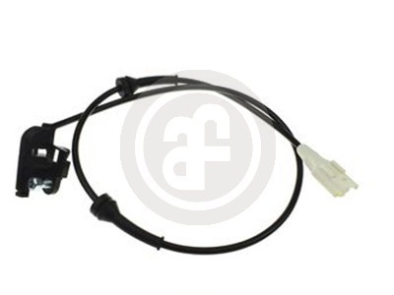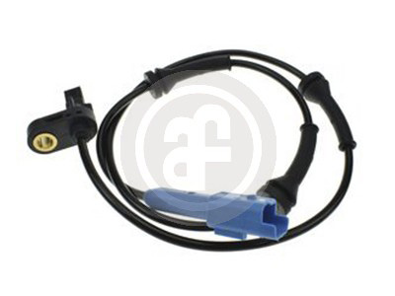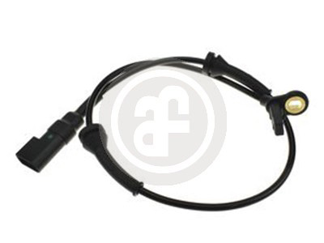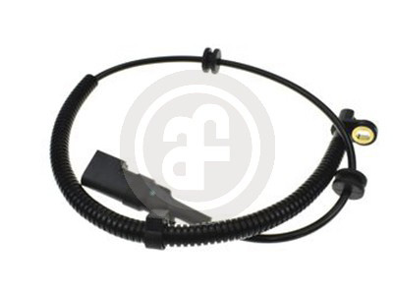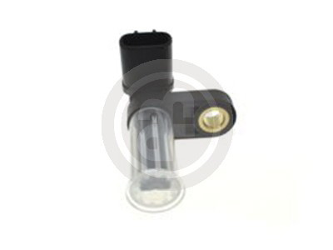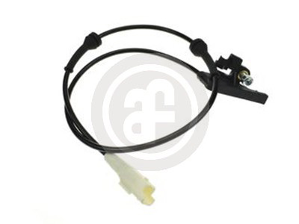

|  |  |  |  |  |  |  |  |  |  |  |  |  |  |  |  |  |
| --- | --- | --- | --- | --- | --- | --- | --- | --- | --- | --- | --- | --- | --- | --- | --- | --- |
| **DS0062** | | | | | | |  | | --- | | **DS0063** | | | | | | | | | | |
| **Active sensor** | | | | **JAGUAR** | C2S17482 | **LEXUS**  **TOYOTA** | | | | | | | | 8954260050 8954260050 | |
| **JAGUAR** | C2S2340 |
| **JAGUAR** | | | | | C2S43216 |
| **FORD** | | | | | 1115018 |
| **FORD** | | | | | 1146400 |
| **FORD** | | | | | 1386268 |
| **FORD** | | | | | 1S7T2B372AB |
| **FORD** | | | | | 1S7T2B372AC |
| **FORD** | | | | | 1S7T2B372AD |
| A = | 25,2 | mm | B = | mm | | A = | | 27,6 | mm | B = | mm | | | | |
| **DS0064 (coming soon)** | | | | | | |  | | --- | | **DS0065** | | | | | | | | | | |
| **Active sensor** **HYUNDAI** A = 15,2mmB = 890mm | | | | | 956701R000 | **Active sensor** | | | | | **PSA** | 454508 | | | |
| **PSA** | 4545L0 | | | |
| A = | | mm B = | | | 725mm | | | | |
| **DS0067 (coming soon)** | | | | | | |  | | --- | | **DS0068 (coming soon)** | | | | | | | | | | |
| **Active sensor** **HYUNDAI** A = 21,2mmB = 870mm | | | | | 956801R000 | **Active sensor** | | | | | **HYUNDAI** | | | | 956811R000 |
| A = | | 21,5 | mm | B = | 845mm | | | | |
| **DS0069** | | | | | | |  | | --- | | **DS0070** | | | | | | | | | | |
| **Active sensor** | | | | **BMW** | 34526762466 | **Passive sensor** | | | | | **OPEL** | 1238917 | | | |
| A = | 30,9 | mm | B = | 870mm | | **OPEL** | 90386505 | | | |
| A = | 48,5 | | mm | B = | 1050mm | | | | |
| **DS0071** | | | | | | |  | | --- | | **DS0072** | | | | | | | | | | |
| **Passive sensor** | | | | **OPEL** | 1238918 | **Active sensor** | | | | | **BMW** | | 34526762465 | | |
| **OPEL** | 6238429 |
| **OPEL** | | | | | 9012161 | A = | | 31 | mm | B = | 585mm | | | | |
| **OPEL** | | | | | 90386504 |
| **OPEL** | | | | | 90483637 |
| **OPEL** | | | | | 93169315 |
| A = | 28,1 | mm | B = | 507mm | |
|  | | | | | |
|  |  | | | | | | | | |
|  | | | | | 11 | | | | |

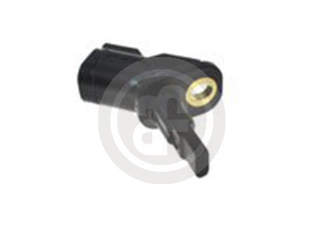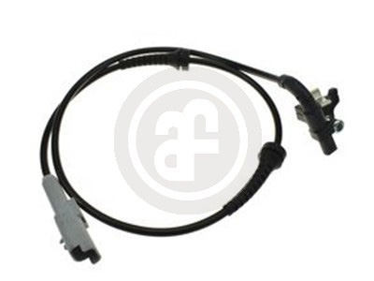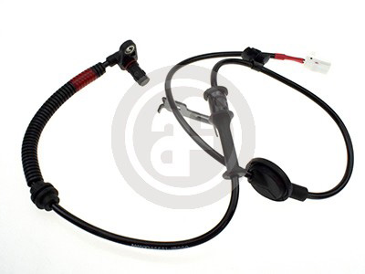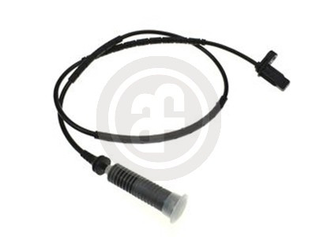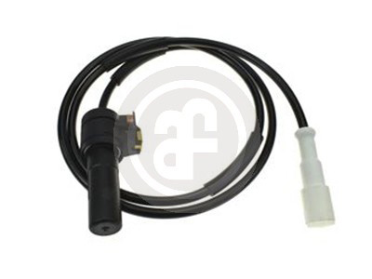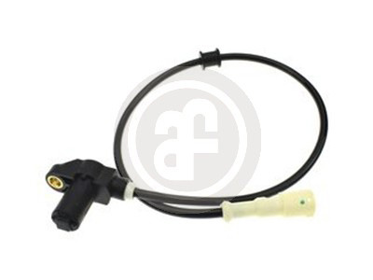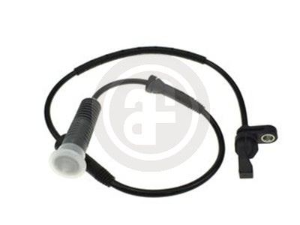

|  |  |  |  |  |  |  |  |  |  |  |  |  |  |  |
| --- | --- | --- | --- | --- | --- | --- | --- | --- | --- | --- | --- | --- | --- | --- |
| **DS0073** | | | | | | | |  | | --- | | **DS0074** | | | | | | | |
| **Active sensor** | | | **TOYOTA** | | | 8954302060 | **Active sensor** **TOYOTA**  **TOYOTA**A = 29mmB = 104mm | | | | | | 8954202060 8954202061 |
| **TOYOTA** | | | 8954302061 |
| A = | 29 | mm | B = | 100mm | | |
| **DS0075** | | | | | | | |  | | --- | | **DS0076** | | | | | | | |
| **Passive sensor** A = 30,6mmB = 962mm | | | | | **CITROËN** | 454578 | **PSA**   **PSA** | | | | | | 45450000 4545J8 |
| A = | | 27,2 | mm | B = | 690mm | |
| **DS0077** | | | | | | | |  | | --- | | **DS0078** | | | | | | | |
| **RENAULT** | | | | | | 7700411745 | **Passive sensor** | | | | | **RENAULT** | 7700411746 |
| A = | 28,1 | mm | B = | 708mm | | | A = | | 28,1 | mm | B = | 1580mm | |
| **DS0079** | | | | | | | |  | | --- | | **DS0080 (coming soon)** | | | | | | | |
| **Active sensor** **FORD**   **FORD**  **MAZDA**A = 14mmB = 1200mm | | | | | | 1151023 2S612B372BDD3514371YA | **Passive sensor** | | | | | **HYUNDAI** | 956701R100 |
| A = | 15 | | mm | B = | 900mm | |
| **DS0081 (coming soon)** | | | | | | | |  | | --- | | **DS0082** | | | | | | | |
| **Active sensor** | | | **HYUNDAI** | | | 956711R000 | **OPEL** **OPEL** **OPEL** **OPEL** **OPEL** **OPEL** | | | | | | 1238265 12842287 13470636 23483147 6238265 6238613 |
| A = 15,35mm | | | B = | 890mm | | | A = | | 36,7 | mm | B = | 300mm | |
| 12 | | | | | | |
|  |  | | | | | |
|  | | | | | | |

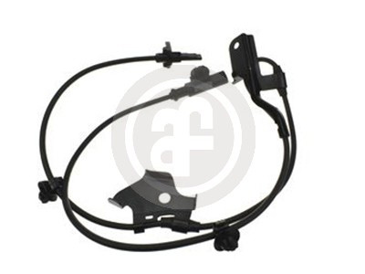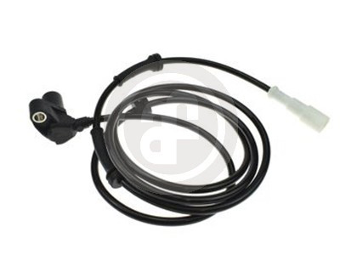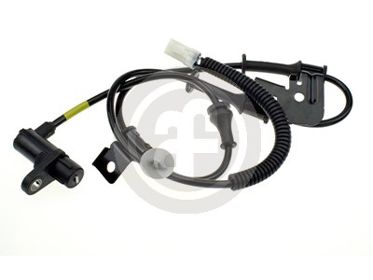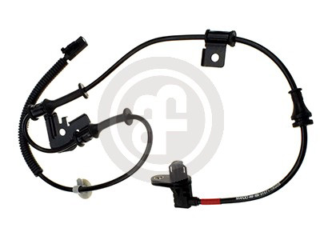

|  |  |  |  |  |  |  |  |  |  |  |  |  |  |  |  |  |
| --- | --- | --- | --- | --- | --- | --- | --- | --- | --- | --- | --- | --- | --- | --- | --- | --- |
| **DS0083** | | | | | |  | |  | | --- | | **DS0084** | | | | | | | | | |
| **Passive sensor**  A = 20,9mmB = 1030mm | | | | | **TOYOTA** | 8954202040 | **Active sensor** **PSA**  A = 27,3mmB = 680,8mm | | | | | | | | 9805066080 |
| **DS0086** | | | | | |  | |  | | --- | | **DS0087** | | | | | | | | | |
| **Passive sensor** | | | | **VAG** | | 8E0927803B | **Active sensor** | | | | | | **RENAULT** | | 8200043135 |
| A = | 28,1 | mm | B = | 957mm | | **RENAULT** | | 8200296570 |
| **RENAULT** | | | | | | | | 8200346992 |
| A = | | 12,5 | mm | B = | 490mm | | | |
| **DS0088** | | | | | |  | |  | | --- | | **DS0089** | | | | | | | | | |
| **Active sensor** | | | | **RENAULT**  **RENAULT** | | 479001745R | **Active sensor** **RENAULT**  **RENAULT** **RENAULT**A = 28mmB = 716mm | | | | | | | | 479006554R60400045248200254681 |
| 6040004527 |
| **RENAULT** | | | | | | 8200254685 |
| A = | 28 | mm | B = | 1585mm | |
| **DS0090** | | | | | |  | |  | | --- | | **DS0091** | | | | | | | | | |
| **Active sensor** | | | | **PSA** | | 4545F6 | **Active sensor** | | | | | | **FORD** | | 1516502, 1526034 |
| **FORD** | | 1560622, 1678466 |
| A = | mm B = | | | 718mm | | **FORD**  **FORDFORDFORDFORDFORDFORDFORD** | | | | | | | | 1761079, 17668431771552 8V512C204AB 8V512C204AC 8V512C204AD 8V512C204AE 8V512C204AF 8V512C204BA |
| A = | 28 | | mm | B = | 650mm | | **FORD** | 8V512C204BB |
| **DS0092** | | | | | |  | |  | | --- | | **DS0093 (coming soon)** | | | | | | | | | |
| **Active sensor** | | | | **FORD**  **FORD** | | 1514205 | **Active sensor** **HYUNDAI** A = 37,18mmB = 1180mm | | | | | | | | 956802B000 |
| 1525681 |
| **FORD** | | | | | | 1761113 |
| **FORD** | | | | | | 2094988 |
| **FORD** | | | | | | 8V512B372AB |
| **FORD** | | | | | | 8V512B372AC |
| **FORD** | | | | | | 8V512C190AA |
| **FORD** | | | | | | 8V512C190AB |
| A = | 9,6 | mm | B = | 585mm | |  |
|  |  | | | | | | | |
|  | | | | | | | | 13 |

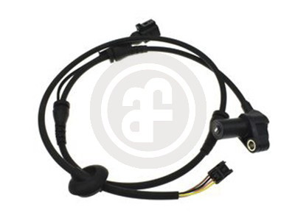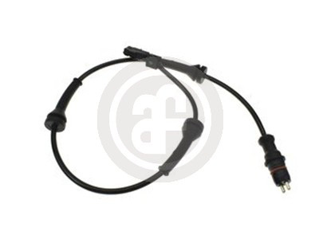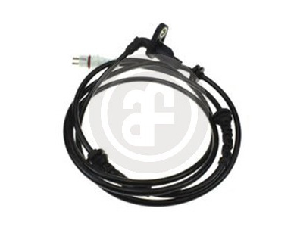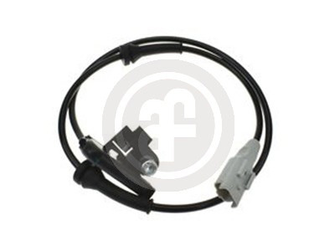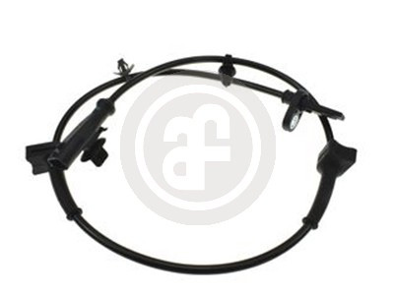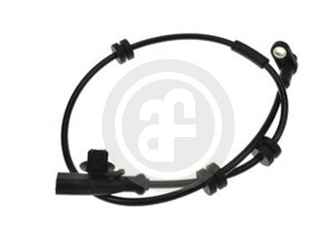

|  |  |  |  |  |  |  |  |  |  |  |  |  |  |  |
| --- | --- | --- | --- | --- | --- | --- | --- | --- | --- | --- | --- | --- | --- | --- |
| **DS0094 (coming soon)** | | | | | | |  | | --- | | **DS0095** | | | | | | | | |
| **Active sensor** **HYUNDAI** A = 37,14mmB = 1160mm | | | | | 956812B000 | **Active sensor** | | | | **MERCEDES** | | | 2035400417 |
| A = | | 31 | mm | B = | 580mm | | |
| **DS0096** | | | | | | |  | | --- | | **DS0097** | | | | | | | | |
| **Passive sensor** **VAG**  A = 28mmB = 1330mm | | | | | 8E0927807B | **Active sensor** | | | | **MERCEDES** | | | 1695400417 |
| **MERCEDES** | | | 1695401117 |
| **MERCEDES** | | | | | | | 1695401417 |
| A = | | 28,1 | mm | B = | 610mm | | |
| **DS0098** | | | | | | |  | | --- | | **DS0099** | | | | | | | | |
| **Active sensor** | | | **MERCEDES** | | 1695400817 | **Active sensor** | | | | **NISSAN** | | | 47910JD000 |
| **MERCEDES** | | 1695401217 |
| **MERCEDES** | | | | | 1695401517 | A = | | 39,2 | mm | B = | 711mm | | |
| A = | 17,1 | mm | B = | 470mm | |
| **DS0100** | | | | | | |  | | --- | | **DS0101** | | | | | | | | |
| **Active sensor** | | | **BMW** | | 34526764610 | **Active sensor** | | | | **OPEL** | | | 1247003 |
| A = | 39,2 | mm | B = | 880mm | | **OPEL** | | | 1247166 |
| **OPEL** | | | | | | | 13324530 |
| **OPEL** | | | | | | | 13346945 |
| **OPEL** | | | | | | | 13470643 |
| **OPEL** | | | | | | | 6238643 |
| A = | 36,7 | | mm | B = | 570mm | | |
| **DS0102** | | | | | | |  | | --- | | **DS0103 (coming soon)** | | | | | | | | |
| **Active sensor** **PSA**   A = 34,1mmB = 933mm | | | | | 4545C9 | **Active sensor**  A = 19,7mmB = 1070mm | | | | | | **HYUNDAI** | 956702B200 |
| 14 | | | | | |
|  |  | | | | | | |
|  | | | | | | | |

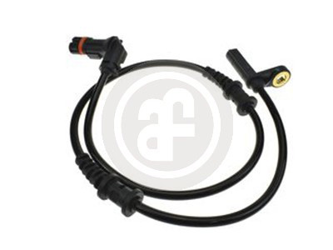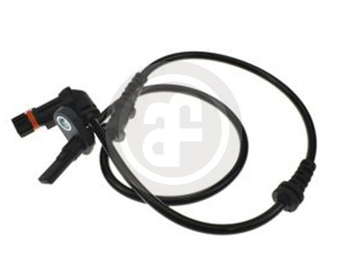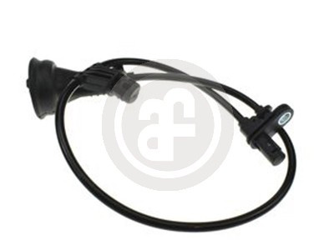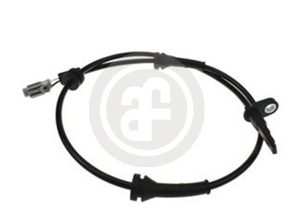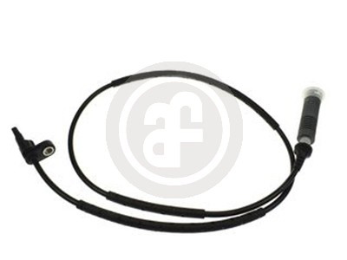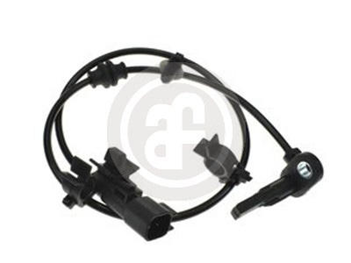

|  |  |  |  |  |  |  |  |  |  |  |  |  |  |  |  |  |  |  |  |  |  |  |
| --- | --- | --- | --- | --- | --- | --- | --- | --- | --- | --- | --- | --- | --- | --- | --- | --- | --- | --- | --- | --- | --- | --- |
| **DS0104 (coming soon)** | | | | | | | | | |  | | --- | | **DS0105 (coming soon)** | | | | | | | | | | | | | |
| **Active sensor** | | | | | | **HYUNDAI** | 956702B210 | | **Passive sensor** | | | | | | | **VAG** | 3B0927807H | | | | |
| A = | 19,7 | mm | B = | 1075mm | | | | |
| A = 28,05mm | | | | B = | 1220mm | | | | | | | |
| **DS0106** | | | | | | | | | |  | | --- | | **DS0107** | | | | | | | | | | | | | |
| **Active sensor** | | | **RENAULT** | | | | 479000010R | | **DACIA**  **DACIA** **RENAULT** **RENAULT** | | | | | | | | | | 479104225R479104991R479104225R479104991R | | |
| **RENAULT** | | | | 479006271R | |
| A = | 23,6 | mm | B = | | 805mm | | | | A = | | 38 | mm | B = | | 600mm | | | | | | |
| **DS0108** | | | | | | | | | |  | | --- | | **DS0109** | | | | | | | | | | | | | |
| **Active sensor** A = 41,7mmB = 869mm | | | | | | **MITSUBISHI** | | 4670A575 | **Active sensor** | | | | **MITSUBISHI** | | | | | | | | 4670A576 |
| A = | | 41,7 | mm | B = | | 890mm | | | | | | |
| **DS0110** | | | | | | | | | |  | | --- | | **DS0111** | | | | | | | | | | | | | |
| **Active sensor** | | | **MERCEDES** | | | | 2035401317 | | **Active sensor** | | | | **MERCEDES** | | | | | | | 2035401417 | |
| A = | 31 | mm | B = | 1115mm | | | | | A = | 31 | | mm | B = | 960mm | | | | | | | |
| **DS0112 (coming soon)** | | | | | | | | | |  | | --- | | **DS0113** | | | | | | | | | | | | | |
| **Passive sensor** **VAG**   A = 34mmB = 1240 mm | | | | | | | 6U0927807 | | **BMW**  **BMW** | | | | | | | | | 34526791225 34526884421 | | | |
| A = | | 38,7 | mm | B = | | 790mm | | | | | | |
|  | | | | | | | | |
|  |  | | | | | | | | | | | |
|  | | | | 15 | | | | | | | | |

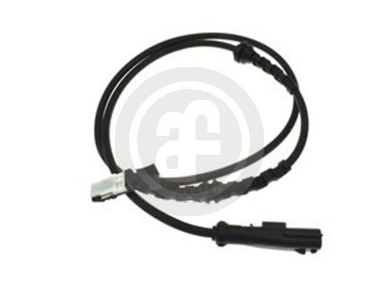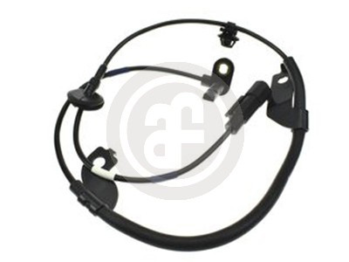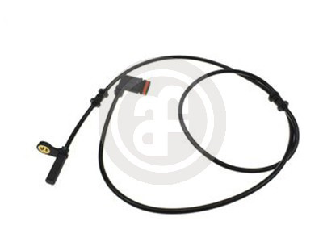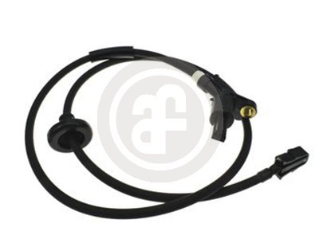

|  |  |  |  |  |  |  |  |  |  |  |  |  |  |  |
| --- | --- | --- | --- | --- | --- | --- | --- | --- | --- | --- | --- | --- | --- | --- |
| **DS0114** | | | | | | | |  | | --- | | **DS0115** | | | | | | | |
| **Passive sensor** | | | | **CITROËN** | | 454533 | **Active sensor** **RENAULT** A = 28,3mmB = 441,5mm | | | | | | 8200254687 |
| **CITROËN** | | 454536 |
| **CITROËN** | | | | | | 454546 |
| **CITROËN** | | | | | | 96089629 |
| **CITROËN** | | | | | | 96217753 |
| A = | 30,6 | mm | B = | 750mm | | |
| **DS0116** | | | | | | | |  | | --- | | **DS0117** | | | | | | | |
| **Active sensor** | | | | **DACIA** | | 8200254688 | **Active sensor** **PSA**   A = mm B = 628mm | | | | | | 454588 |
| **RENAULT** | | 8200254688 |
| A = | 24,8 | mm | B = | 445mm | | |
| **DS0120** | | | | | | | |  | | --- | | **DS0122** | | | | | | | |
| **Active sensor** | | | | **PSA** | | 4545H7 | **Active sensor** | | | | **OPEL** | | 1247004 |
| **PEUGEOT** | | 454589 |
| **OPEL** | | 13329258 |
| **PEUGEOT** | | | | | | 96353848 |
| **OPEL** | | | | | | 13470637 |
| **PEUGEOT** | | | | | | 96436605 |
| **OPEL** | | | | | | 6238636 |
| **PEUGEOT** | | | | | | 96436808 |
| **PEUGEOT** | | | | | | 96449668 | A = | | 36,7 | mm | B = | 800mm | |
| A = | mm B = | | | 740mm | | |
| **DS0134 (coming soon)** | | | | | | | |  | | --- | | **DS0166** | | | | | | | |
| **Active sensor** **FIAT**  A = 44,5mmB = 1430 mm | | | | | | 51737851 | **MERCEDES**  **MERCEDES** | | | | | | 20454001172049050000 |
| A = | 31 | | mm | B = | 633mm | |
| **DS0169** | | | | | | | |  | | --- | | **DS0171 (coming soon)** | | | | | | | |
| **Active sensor** A = 23,6mmB = 1110mm | | | | | **NISSAN** | 47910AX600 | **Active sensor** **PSA**  A = 38mmB = 950mm | | | | | | 4545H2 |
| **NISSAN** | 47910AX610 |
| 16 | | | | | | |
|  |  | | | | | |
|  | | | | | | |

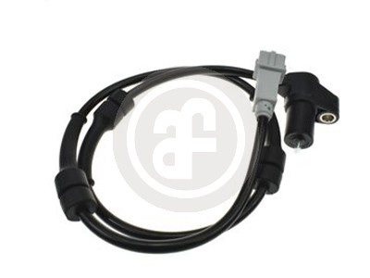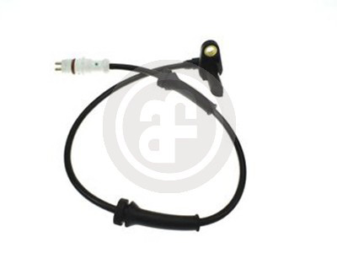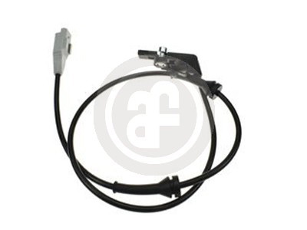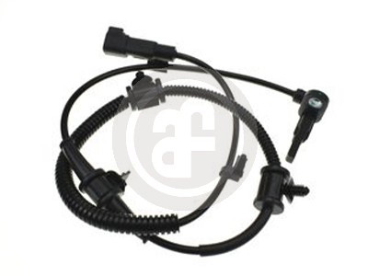

|  |  |  |  |  |  |  |  |  |  |  |  |  |  |  |  |  |  |  |  |  |  |  |  |
| --- | --- | --- | --- | --- | --- | --- | --- | --- | --- | --- | --- | --- | --- | --- | --- | --- | --- | --- | --- | --- | --- | --- | --- |
| |  | | --- | | **DS0177 (coming soon)** | | | | | | | | | | | |  | | --- | | **DS0178 (coming soon)** | | | | | | | | | | | | |
| **Passive sensor** | | | **VAG** | | | | | 2D0927807 | | **VAG**   **MERCEDES** **MERCEDES** | | | | | | | | | | | 2D0927807A90154211179015421817 |
| **MERCEDES** | | | | | 9015420118 | |
| **MERCEDES** | | | | | | | | 9015420817 | |
| **MERCEDES** | | | | | | | | 9015421717 | |
| A = | 77 | mm | B = | 2230mm | | | | | | A = | | 77 | mm | B = | 1740mm | | | | | | |
| |  | | --- | | **DS0180** | | | | | | | | | | | |  | | --- | | **DS0181** | | | | | | | | | | | | |
| **Active sensor** | | | **CITROËN** | | | | | 1627162680 | | **Active sensor** **PSA**   A = mm B = 725mm | | | | | | | | | | 4545C3 | |
| **CITROËN** | | | | | 4545H1 | |
| **FIAT** | | | | | | | | 51725100 | |
| **FIAT** | | | | | | | | 51787753 | |
| **FIAT** | | | | | | | | 52057984 | |
| **FIAT** | | | | | | | | 52091139 | |
| A = | 38,2 | mm | B = | | 950mm | | | | |
| |  | | --- | | **DS0183** | | | | | | | | | | | |  | | --- | | **DS0184** | | | | | | | | | | | | |
| **Passive sensor** | | | **DAEWOO** | | | | | 96455870 | | **Active sensor** | | | | | | | **FORD** | | | 1151951 | |
| **DAEWOO** | | | | | 96549713 | |
| **FORD** | | | 1207357 | |
| **CHEVROLET** | | | | | | | | | 96455870 |
| **FORD** | | | | | | | | | | 1698686 | |
| **CHEVROLET** | | | | | | | | | 96549713 |
| **FORD** | | | | | | | | | | 2N112B372AA | |
| A = | 28 | mm | B = | | 715mm | | | | | **FORD** | | | | | | | | | | 2N112B372AB | |
| **FORD** | | | | | | | | | | 2S612B372AD | |
| A = | | 25 | mm | B = | | 710mm | | | | | |
| |  | | --- | | **DS0191** | | | | | | | | | | | |  | | --- | | **DS0195** | | | | | | | | | | | | |
| **Passive sensor** A = 28mmB = 715mm | | | | | | **DAEWOO** | | | 96455869 | **Passive sensor**  A = 28mmB = 735mm | | | | | | | | | **SUZUKI** | 5621062J00 | |
| **DAEWOO** | | | 96549712 |
| **SUZUKI** | 5621062J01 | |
| **CHEVROLET** | | | 96455869 |
| **SUZUKI** | 5621062J02 | |
| **CHEVROLET** | | | 96549712 |
| |  | | --- | | **DS0196** | | | | | | | | | | | |  | | --- | | **DS0222** | | | | | | | | | | | | |
| **Passive sensor** A = 28mmB = 755mm | | | | | | | **SUZUKI** | 5622062J00 | | **Passive sensor** | | | | | | | | **DAEWOO** | | 96316715 | |
| **SUZUKI** | 5622062J01 | | **DAEWOO** | | 96569341 | |
| **SUZUKI** | 5622062J02 | |
| A = | | 19,1 | mm | B = | | 645mm | | | | | |
|  | | | | | | | | | |
|  |  | | | | | | | | | | |
|  | | | | | | | | | | 17 | |

